

INSTRUCTION GUIDE

(Questions and feedback? Try r/pokemonmastertrainer, message u/dcandal on reddit or tweet at @dcandal)

**Index**

**1. CONTENT** 4

**2. QUICK SETUP** 6

**3. THE BOARD** 9

**3.1) Traveling:** 9

**3.2) Spaces on the board:** 9

**3.3) Cities:** 10

**3.4) The hexagons:** 10

**3.5) Special passages:** 11

**4. THE POKÉMON** 13

**4.2) Battling:** 14

4.2.1) Using the Stadium 16

4.2.2) Healing Fainted Pokémon 17

4.2.3) Duel Events 17

**4.3) Evolving:** 17

4.3.1) Eevee and its evolutions 18

**4.4) Trading** 18

**4.5) Legendary Pokémon:** 18

**5. GYM LEADERS AND BADGES** 19

**5.1) Preparing the Gyms**: 19

**5.2) Gym Battle**: 20

**5.3) Badge rewards**: 21

**5.4) Locking and upgrading a Pokémon**: 21

**6. INDIGO PLATEAU AND POKÉMON LEAGUE** 22

**6.1) Head-to-Head League:** 23

6.1.1) **6 players** 23

6.1.2) **5 players** 24

6.1.3) **4 players** 25

6.1.4) **3 players** 25

6.1.5) **2 players** 26

6.1.6) **Battles** 26

**6.2) Elite 4 League:** 27

6.2.1) **Rules** 27

6.2.1) **Battling the Elite Trainers** 27

**7. ITEM GUIDE** 29

**8. EVENT GUIDE** 33

**9. SUPER EVENT GUIDE** 39

**10. TRAINER CARD GUIDE** 42

**11. APPENDIX: POKÉMON EVOLUTION GUIDE / POWER CHART** 45

**DRAGON** 45

**DARK/GHOST** 45

**ELECTRIC** 45

**FIRE** 45

**FLYING** 46

**GRASS/BUG** 46

**GROUND** 46

**ICE/FAIRY** 46

**NORMAL/STEEL** 47

**POISON** 47

**PSYCHIC** 47

**ROCK/FIGHTING** 47

**WATER** 48

# **1. CONTENT**

|  |  |
| --- | --- |
|  | **POKÉMON CARDS:** These are your Pokémon. There are six different colors for them, depending on how strong they are. Check section **4**. **POKÉMON GUIDE** for more details. |
|  | **EVENT CARDS**: The world of Pokémon is full of people, places and events that you can find at any time. These cards are drawn **whenever you land on the ‘!’ space on the board**.  When buying one of these just activate the command on the card.  Check section **8. EVENT GUIDE** for individual explanations on the cards. |
|  | **SUPER EVENTS**: These are like Event Cards, but stronger. Drawn whenever you land on the **yellow “!” space on the board**, they’re only found in the Indigo Plateau, right before the Pokémon League starts, but in rare ocasions can be found outside of it.  Check section **9. SUPER EVENT GUIDE** for individual explanations on the cards. |
|  | **ITEM CARDS:** These are items to help you in your journey, acquired through many ways. You can keep **up to 6 items in your hands**.  Check section **7. ITEM GUIDE** for individual explanations on the cards. |
|  | **TRAINER CARDS:** These represent your specialty as a trainer. Every player has one trainer card active at all times, these provide you with various bonuses.  You can only have one Trainer Card at a time – always discard any excess at the end of your turn.  Check section **10. TRAINER GUIDE** for individual explanations on the cards. |

|  |  |
| --- | --- |
|  | **GYM LEADERS:** These are the Gym Leaders you must defeat to earn badges. They sit adjacent to the hexagon of their Gym.  Check section **5**. **GYM LEADERS AND BADGES** for more details. |
|  | **GAMEPADS:** This is a personal space for each trainer to organize their Pokémon, Trainer Card and Badges.  There is also a dice roller there. |
|  | **ELITE TRAINERS:** These are the some of the greatest Pokémon Trainers in the world. You will fight them if you choose the “Elite 4 Mode” for the League.  Check section **6**. **INDIGO PLATEAU AND POKÉMON LEAGUE,** specially **6.2 ELITE 4 LEAGUE** for more details. |

# **2. QUICK SETUP**

**1.0) Using the script:** you can use the 3 script buttons located on a pad below the arena to the right. The first one (“Place Maps”) will shuffle and set the hexagons. The second one will place Pokémon Cards and Gym Leaders on the empty spaces. And the last one will give seated players a random starter, a random Item Card and a random Trainer Card. The red circle in the image below shows where you can find the Script Buttons:

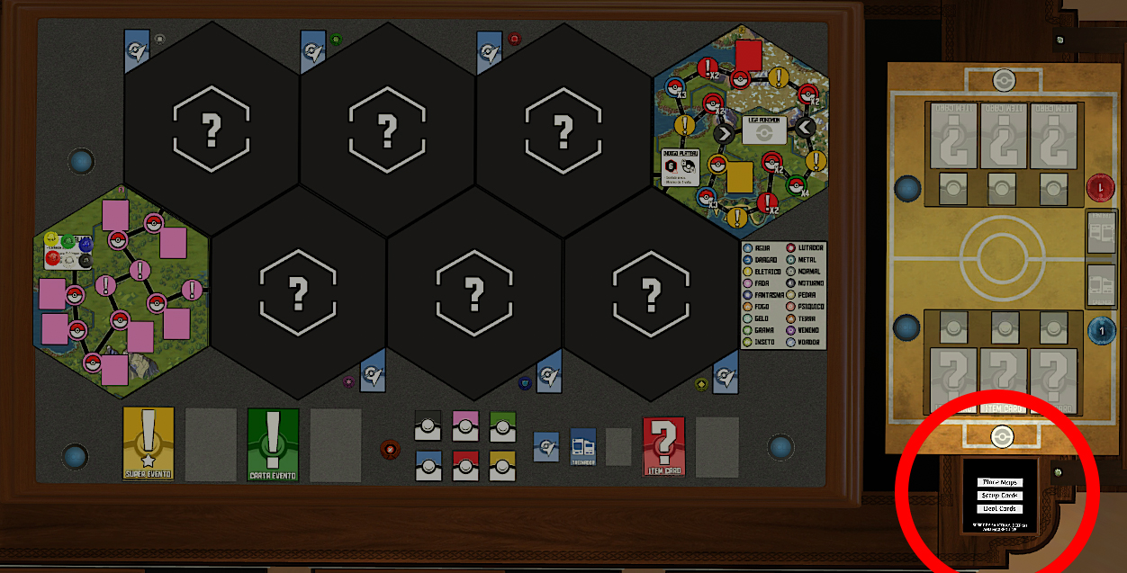

If you’re playing with less than 6 players, check the section 1.3 of the manual setup below that shows how to add unused starters to the game.

If you are an experienced player, you can also check alternative starters (for more information on that just read the section 1.4 of the manual setup below).

For a manual setup:

**1.1) Prepare the board:** find and shuffle the small colored trunks in the lower left corner of the board. Grab two tier 1 (green), two tier 2 (blue) and two tier 3 (red) and lock them in the board as shown in the picture below:

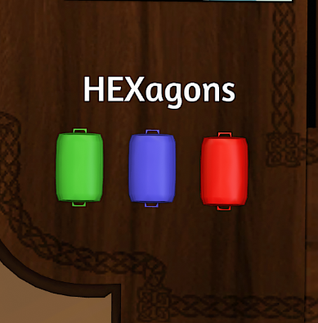 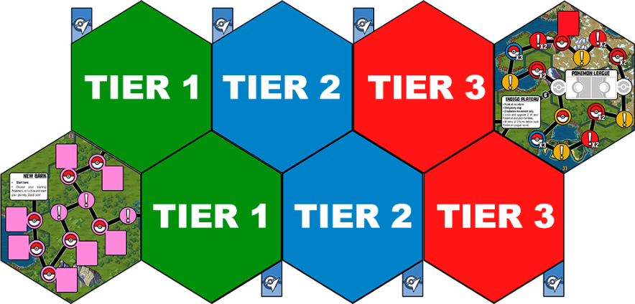

|  |  |  |
| --- | --- | --- |
| **1.2) Get your starter Pokémon:** shuffle the Starter Pokémon pile (gray back, like the picture to the right) and deal one to each player participating. |  | |
| **1.3) (OPTIONAL) Add unused starters to the game if you’re playing with less than 6 players.** After dealing the starters, check which starter Pokémon were not dealt to any players, then, to the left of the main board you will see the Inactive Pokémon. There you can find duplicates for those starters on the piles for that Pokémon’s Generation.  **1.4) (OPTIONAL) Add Inactive Pokémon if you want to.** If you are a more experienced player and want a Pokémon that is not currently on the game, you can check the Inactive Pokémon tokens to the left of the board. The active roster is balanced for 6 players and picked in order to keep the types balanced, but if you can find any Pokémon you’d like, just add them to the game. | |  |
| **1.5) Get an Item and a Trainer for everyone:** just give one Item Card and one Trainer Card to each player participating.  They’re the blue and red cards shown in the picture to the right. Items are private and kept in the players’ hands. Trainers are public and displayed on their pad. (A player can only hold up to 6 Item Cards and 1 Trainer Card). |  | |
| **1.6) Place the wild Pokémon:** shuffle thePokémon cards and place them on the empty rectangular spaces on the board, match the color of the boardspace to the color on the back of the Pokémon chip, like the picture to the right. |  | |

**1.7) Choose a Pokémon League format.** Check Section 6: Indigo Plateau and Pokémon League: there are two types of Pokémon League: Head-to-Head Mode and Elite 4 Mode. Choose one of them. You can check section **6. INDIGO PLATEAU AND POKÉMON LEAGUE** for more information.

**1.8) Roll the dice and start your journey.** Shuffle the Event, Super Events and we are ready to go. The game starts in New Bark Town, on the lower left hexagon where the pawns already are. Decide who goes first and just roll a six-sided dice. For more detailed information just read the rest of this guide.

# **3. THE BOARD**

## **3.1) Traveling:**

On your turn, roll one six-sided dice. Move your pawn that number of spaces along the board, following the black lines connecting the spaces.

You can always travel in any direction you want on your turn, but you can’t change directions while traveling (for instance, if you rolled a 6, you may not move past a specific Pokémon, then reverse the Direction to land exactly on it).

Also, you cannot pass through the same space more than once in a turn.

More than one player can occupy the same space without problems.

## **3.2) Spaces on the board:**

Let’s first explore the main **spaces** on the board:

|  |  |
| --- | --- |
|  | Reveal and try to **capture the Pokémon** in this space.  If you suceed, replace the Pokémon with another one (of the same color) in the face-down position.  If you fail, keep the revealed Pokémon face-up and add a Weakened Token to them. |
|  | Draw an **Event Card** and activate it. Show the other players or read it out loud so everybody understands what you’re doing. After that discard the Event to the discard pile on the side. |

## **3.3) Cities:**

The following space is a city. You can ALWAYS stop at a city, you don’t need to roll the exact number in the dice to stop there:

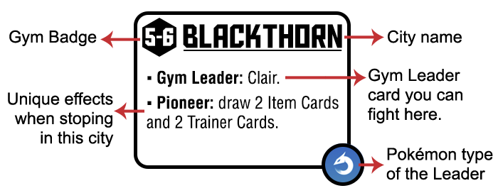

There are two kinds of effects on a city: **PIONEER** and **FIRST VISIT**:

|  |  |
| --- | --- |
| - **Pioneer**: that effect is only applied to the first player to reach this city | - **First Visit:** that effect is applied to every player when they first stop there. |

Some cities will have both the Pioneer AND the First Visit effects.

You can also take the magnet train between cities you have already visited. Whenever on a city space you can use your turn to go a city you have already visited instead of rolling a movement dice.

Whenever you land on a City you can fight its Gym Leader, you don’t need an extra turn to do that. You can also stay at a city you’re currently in at the start of your turn, so if you lost a battle against a Gym Leader, you can stay there and fight again on your next turn.

## **3.4) The hexagons:**

The board is divided in EIGHT HEXAGONS like you can see in the following picture. The first (lower left) and last (top right) hexagons are always the same, but in every game the six in the middle are randomed.

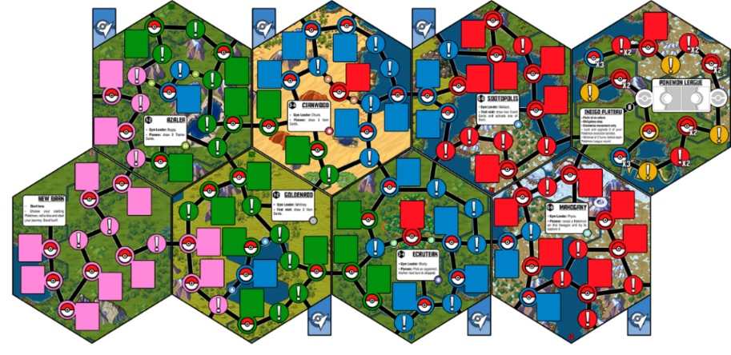

The six in the middle are tiered as shown in the following image:

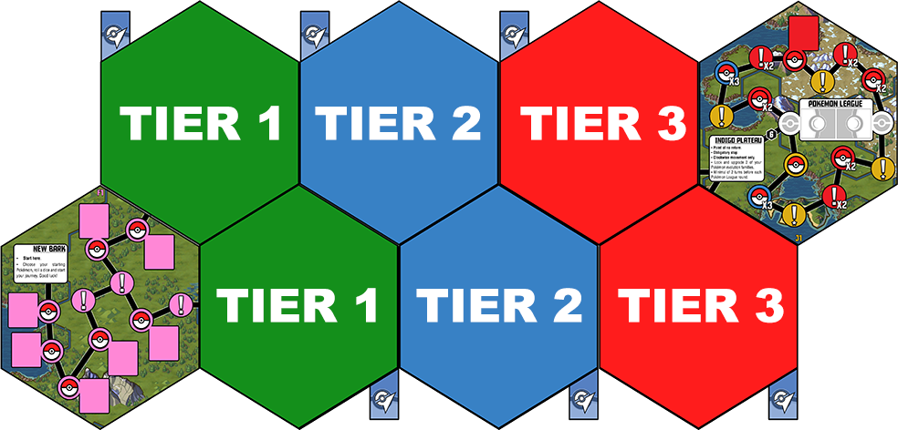

In the Tier 1 Hexagons you will find weaker Pokémon and Gym Leaders. They get stronger as the next tiers come. You are free to explore in whatever order you want. **(on Tabletop Simulator** the hexagons are kept in the colored trunks in the lower left corner of the board.)

## **3.5) Special passages:**

There are some special passages in the board, not always acessible, but will often have stronger Pokémon or stronger Events than the rest of their hexagon.

Type passages are like the one on the picture below. You can only go through them if you have a Pokémon of that type. In that example you can only access the area if you have a Ground Pokémon on your team:

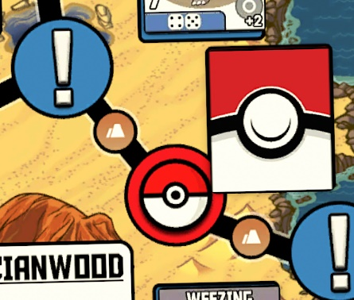

These spaces work like any other spaces, so movement past them cost the same dice numbers as any other.

|  |  |
| --- | --- |
|  | There are also Item passages, like this one on the left.  Whenever you pass or are in the space adjacent to the Item Passage, you can discard the amount of Item Cards shown there to go to that space.  You don’t need to roll an exact number on the dice to access it. And you only need to “pay the Item price” in the direction of the arrow (so you do not get stuck inside). |

On the examples above: any player on Fuchsia or passing through Fuchsia can discard an Item Card and access the space with the Red Pokémon. Also, any player passing by the red event can discard 3 Item Cards and go to the Super Event space.

# **4. THE POKÉMON**

**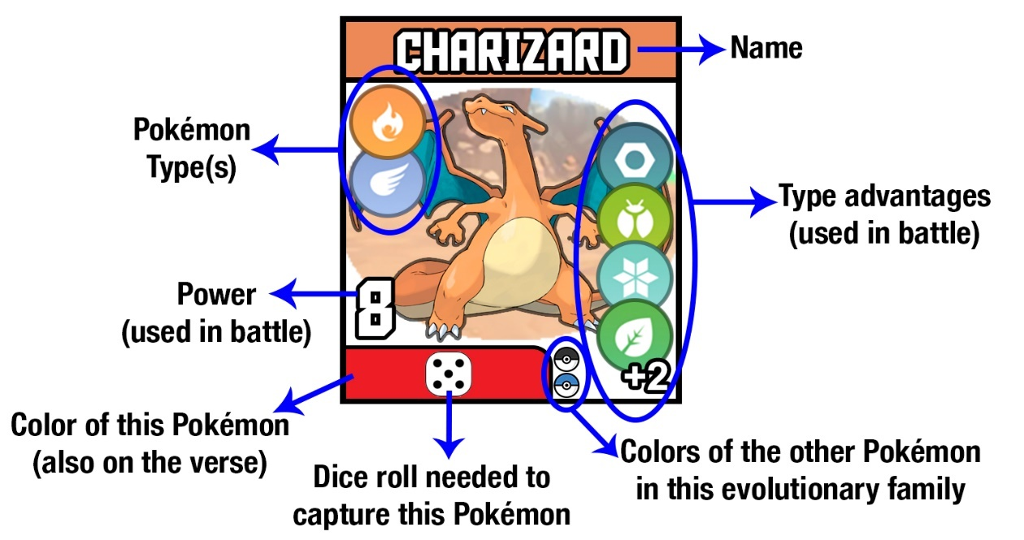  
4.1) Capturing:**

You will need to capture Pokémon to build a strong team. Doing that is pretty simple:

1. When you land on a space with a poké ball on the board, reveal the Pokémon Chip adjacent if he’s face-down.
2. Check the little dice symbols on the bottom of the chip. You must roll one of these numbers on a six-sided dice to capture it. Stronger Pokémon are harder to capture.
3. Poké Ball item cards: you can use Great, Ultra and Master Balls to make a capture easier. You gotta announce you’re using the Item BEFORE you make a roll for a capture. These items allow you to add or subtract a number from the roll you make:

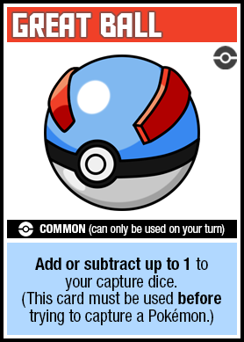 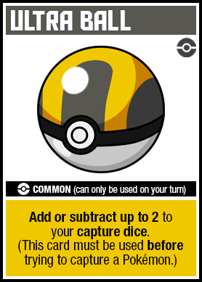 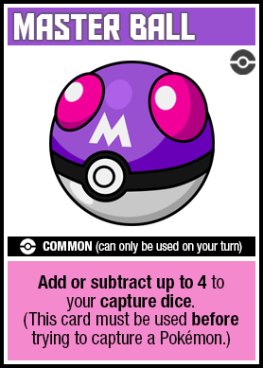

1. If you capture the Pokémon, grab it and keep it in your personal pad with your other Pokémon. Don’t forget to replace the captured Pokémon on the board with a new face-down Pokémon Chip of the same color.
2. If you couldn’t capture the Pokémon, leave it faceup in its space where you found it and add a **Weakened token** to it, like in the picture below. You can add or subtract 1 to the capture roll of a weakened Pokémon and that bonus stacks with any Poké Balls you might use. There can only be **one** weakened token on a Pokémon (so multiple failures do not stack them). Yellow Pokémon do not get weakened.

 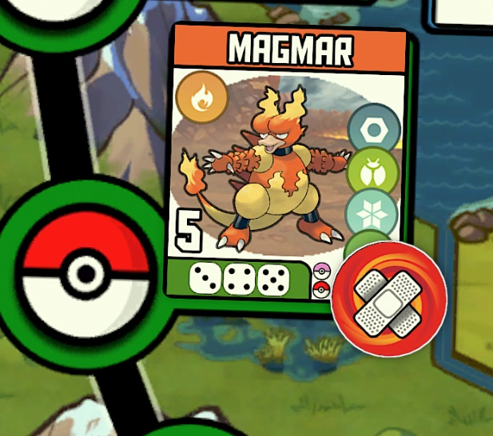

1. The legendary Pokémon (Yellow) are the rarest and can only be found through Event Cards or, very rarely, on special spaces on the board.
2. There is no limit to the amount of Pokémon you can keep.

## **4.2) Battling:**

Pokémon battles will happen in different points of the game. They can happen through some Event Cards, Gym battles and the Pokémon League.

* At the start of the game you can only use your Starter, Pink and Green Pokémon in battle, as you get Gym Badges, stronger Pokémon will also obey you. (Check section **5.3: Badge rewards** for more info)

This is how Pokémon battles work:

1. Pick your Pokémon. Both players should choose their Pokémon and send it to battle.
2. Check the Power of each Pokémon. It’s the white number to the left of the card.
3. Check for type advantages. The type of a Pokémon is to the left of his portrait, and to the right you can see a list of types your Pokémon is effective against. Type advantage grants +2 to the resulting power. (If your Pokémon is against a Pokémon with 2 types and you have an advantage against BOTH of them, they will stack and you will get a +4 to the resulting power).
4. Check both Trainer Cards. Some Trainer Cards add power to different types or different colors of Pokémon.
5. Set a Item Card. There are Item Cards that can increase the power of a Pokémon in a battle. Announce you will use an Item before you roll the dices, just place them face-down on the battle arena. You can bluff and place a non-battle Item Card there, but in doing so the Item Card will still be discarded at the end of the battle. You can’t stack two Item Cards that boost your Pokémon’s power.
6. Both players roll their dices (unless it’s a gym battle, which will be explained in the Gym section).
7. Add dice roll + base power + type effectiveness + bonuses from Item and Trainer Cards. The higher number win.
8. The losing player can use a “Potion” Item Card to reset the battle, discarding any Item Card used previously in battle.
9. In case of a draw both Pokémon faint and the players gotta send another Pokémon to battle. If one player is out of usable Pokémon he loses. If both are out of usable Pokémon, restart the most recent duel.

|  |  |
| --- | --- |
|  | **Battle Example:**  The Picture to the left is an example of a trainer battle:  **1.** Trainer A sends out a Growlithe (4) against Trainer B’s Butterfree (5).  **2.** Growlithe is a Fire Pokémon, so he gets a +2 advantage against Butterfree, since it’s a Bug Pokémon (as shown by the red arrows).  **3.** Trainer A also has the Trainer Card “Blaine”, that adds +1 Power to Fire Pokémon, like Growlithe.  **4.** Trainer B sets the Item Card “Vitamin”, adding +2 to his Butterfree.Trainer A does not set an Item Card.  **5.** They roll 3 and 1, respectively.  **6.** Adding everything, Trainer A has a total of 10 and Trainer B has a total of 8. Trainer A and his Growlithe are the winners. |

### 4.2.1) Using the Stadium

There is a battle arena board to the right of the main board, there you can place the necessary cards for a battle. The blue/red counters can help with keeping track the Pokémon Powers, you can click on it to increase the number displayed. A right-button click will decrease it.

Placing a Pokémon Card (or a Gym Leader) on one of the slots there also brings its 3D Model to the Arena.

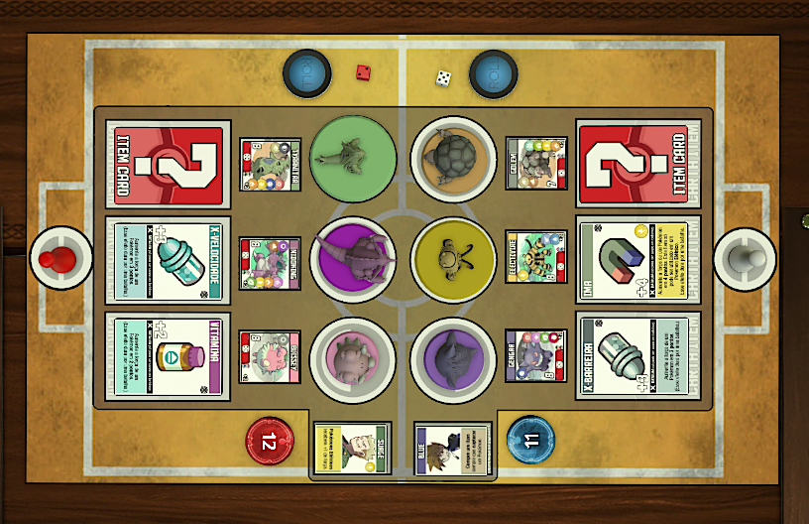

Also, there are hidden zones for each player to place up to 6 Pokémon Cards. Pokémon on these slots will only show to the player of the slot color (so, as an example, the Red player can place Pokémon cards on the Red Slots and only he will see them).

|  |  |
| --- | --- |
| These hidden zones are useful when preparing to battle, speacially the League. Players can place their main Pokémon there, think about who will be sent to battle, and send them face-down to the stadium. |  |

### 4.2.2) Healing Fainted Pokémon

After a battle, a fainted Pokémon is automatically healed/revived. You don’t need to stop on a City’s Pokémon Center or spend healing items on them.

### 4.2.3) Duel Events

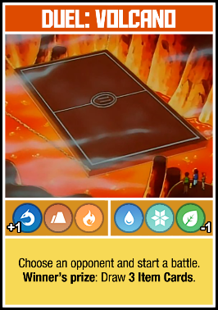 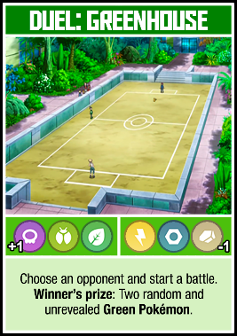 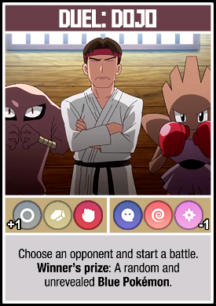 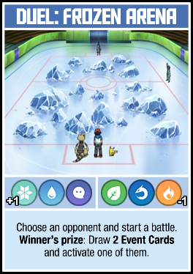

There are some Events that force you to battle someone. These battles work almost like any other, but they happen in places that are good for some types and bad for others.

In the middle of the card there are 3 types that get +1 Power and 3 that get -1, related to the battlefield the Pokémon are fighting on.

There are also good prizes for winning those battles, they are displayed on the bottom of the Event Card.

## **4.3) Evolving:**

Pokémon become stronger as they evolve, so if you collect Pokémon in the same evolution group they will get an evolution bonus. There are Pokémon that evolve once and twice.

|  |  |
| --- | --- |
| **- Set of Two:** If you capture two Pokémon that belong to the same line, add 2 to the power of the more evolved.  This bonus also works if you have only 2 Pokémon from a family of 3, and also works if these two are not the direct sequence (like an Abra and an Alakazam). | **- Set of Three:** If you capture three Pokémon that belong to the same line, add 4 to the power of the more evolved. |

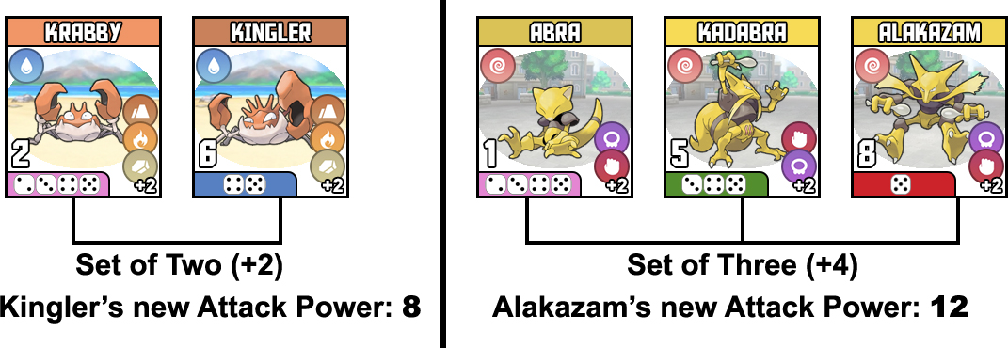

### 4.3.1) Eevee and its evolutions

Eevee is a different type of Pokémon, since it can evolve into many different Pokémon. Because of that, there are two Eevee Pokémon Cards in the game (one Pink and one Green), since there are lots of possible evolutions.

However, Eevee is still treated as a “Set of Two” (+2) evolution. Even if you have both Eevees and even if you have multiple of its evolved forms.

You can, of course, keep those different evolutions to use in different battles since they have different advantages.

## **4.4) Trading**

|  |  |
| --- | --- |
| Does another trainer have a Pokémon you want? Players are free to trade Pokémon whenever they want, in the terms they want. You may offer Item Cards as part of the deal or maybe swap Trainer Cards. It is up to you.  There is also the Trade Event Card (pictured), that forces whoever activated it to trade a Pokémon with another player (one for one, provided both are of the same color). You can get more details about it in the Events section of this guide. |  |

## **4.5) Legendary Pokémon:**

|  |  |
| --- | --- |
| The Yellow Pokémon are the Legendary Pokémon, strongest than any other. They can only be found with rare Event Cards or beyond the Indigo Plateau. If you draw it, shuffle the Yellow Pokémon Pile and draw the next. Try to capture it. If you fail, they go back into the pile. |  |

A Yellow Pokémon WILL NOT get a weakened token if you fail to capture it.

Don’t forget that you need 4 Gym Badges to make a Legendary Pokémon obey you (check **5.3: Badge Rewards** for more info).

# **5. GYM LEADERS AND BADGES**

## **5.1) Preparing the Gyms**:

|  |  |
| --- | --- |
| To become the best you need to win the Pokémon League, and in order to compete in the League you got to fight 6 Gym Leaders and get their badges.  The Gym Leader Cards are located below the hexagons, among other cards, and their back is like the one shown in the picture to the right.  The badges are inside bags by the side of the slots for Gym Leaders, as shown in the yellow circle in the picture below. |  |

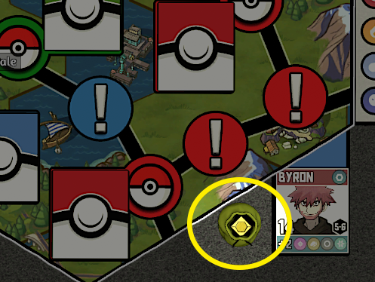



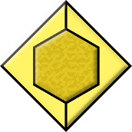



If you’re not using the scripted setup, you also need to put the Gym Leader card close to the hexagon, as shown in the picture above (every hexagon has a slot for that).

|  |  |
| --- | --- |
| The number inside the hexagon show what badge this Leader has (Blaine is 5-6 in the image to the right). That means he can give you the fifth or the sixth badge, depending on how many badges you got.  We have 1-2, 3-4 and 5-6 leaders, so you always have two possibilities to earn the first of these badges. The order is up to you, plan according to your strengths the Leader’s types. |  |

## **5.2) Gym Battle**:

You can battle a Gym Leader when you’re on a City Space once per turn. The fight against a Leader is a little different than a normal battle: The Gym Leader won’t roll a dice, his power is static, displayed in the white number.

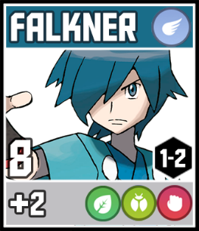 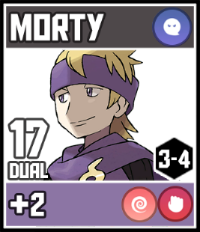 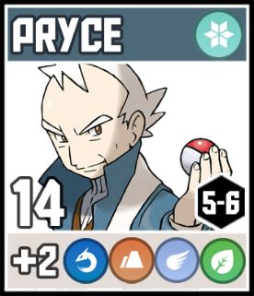

They also have a +2 type effectiveness bonus, shown in the lower part of the card (Falkner, for an example above, has +2 against Grass, Bug and Fighting Pokémon).

|  |  |
| --- | --- |
| The player side of the battle is normal: rolling a dice, adding Trainer Cards, Item Cards and everything that was explained in this guide (see **4.2: Battling**). The only difference is: in case of a **DRAW**, the player wins.  As shown in the picture: you can put Gym Leaders on the Stadium and their Pokémon 3D Model will be brought up. |  |

Some Leaders will have **DUAL** battles (like Morty, above). On those cases, the player will send TWO pokémon to battle, and will roll ONE dice. You can also use up to two items (one for each of your Pokémon). Type effectiveness applies on each of the two Pokémon. Check the example below for a Dual Gym Battle:

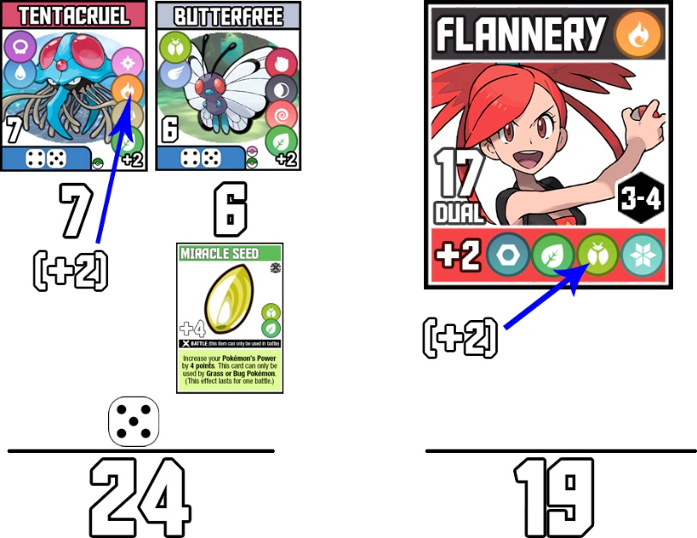

## **5.3) Badge rewards**:

|  |  |
| --- | --- |
| If you win a gym battle, grab a badge from the bag near the Leader you faced and place on your personal pad above the correct number (like in the image to the right). Also, draw an Item Card whenever you win a Gym Leader.  There are also special rewards for every badge, they are:  1 – You can now use Blue Pokémon in battles.  2 – You can now use Red Pokémon in battles.  3 – Win a free, random and unrevealed Blue Pokémon.  4 – You can now use Yellow Pokémon in battles. |  |

5 – Win a free, random and unrevealed Red Pokémon.

6 – Lock and add a +1 marker on one of your Pokémon families

(explained below).

## **5.4) Locking and upgrading a Pokémon**:

The icon to the right can be seen as the 6th badge reward and in the Indigo Plateau, and it means: Lock and upgrade a Pokémon Family, by adding a +1 marker.

So when winning the 6th badge and when arriving on the Indigo Plateau you can choose one of your Pokémon evolutionary lines and upgrade them. These Pokémon will have a permanent +1 to power and will be untradeable. The “untradeable” bonus **covers the whole evolutionary line**.

|  |  |  |
| --- | --- | --- |
| **Example**: You have a Growlithe and an Arcanine and decide to lock this family when you win your 6th badge. Now Arcanine will get a +1 power (stacking with the +2 from evolving) and both Growlithe and Arcanine are protected from Trades. | |  |
| You can also lock a Pokémon you still have no evolutions for, if you’d like. As soon as you get another Pokémon of the same family it will get the “untradeable” bonus. Example: you lock a Dragonite and later manage to capture a Dratini. Both will be untradeable.  There is a +1 token (shown to the right) you can add to your upgraded/locked Pokémon. You can find a bag with those tokens in the lower left corner of the board.  An example of the token in use can be seen in the right. You can use the Attach function in TTS to snap the token to the Pokémon Card. |  | |

# **6. INDIGO PLATEAU AND POKÉMON LEAGUE**

|  |  |
| --- | --- |
| After winning the 6 Gym Badges you can go to the final hexagon and compete in the Pokémon League in order to become the next Pokémon Master and win the game.  You MUST stop in your first visit to the Indigo Plateau space, and can only do that with all 6 badges.  Also, while there, you can lock and upgrade another one of your Pokémon families (check **5.4: Locking and Upgrading a Pokémon**). |  |

After that you can enter the last hexagon. As stated on the Indigo Plateau space, you can only move in one-way inside the final hexagon (the direction showed by the arrows). There are some different, improved spaces inside the League. Here’s how they work:

|  |  |
| --- | --- |
|  | **Super Event**: draw a Super Event Card. |
|  | **Double Event:** draw 2 Event Cards and pick one of them to be activated. |
|  | **Double Capture:** draw the 2 next Red Pokémon (or weaker) from the pile and try to capture one of them. |
|  | **Triple Capture:** draw the 3 next Blue Pokémon (or weaker) from the pile and try to capture one of them. |
|  | **Quadruple Capture:** draw the 4 next Green Pokémon (or weaker) from the pile and try to capture one of them. |
|  | **Enter the Pokémon League:** Start the league. A player must taken at least one full lap on the “Pokémon League loop” in order to activate this space. |

Also, you should decide on the Pokémon League format. There are two of them:

- Head-to-Head Mode: players battle among themselves and one of them will become the Pokémon Master.

- Elite 4 Mode: players challenge the Elite Trainers. The first one to defeat two of them is the Pokémon Master. (More similar to the original Pokémon Master Trainer boardgame).

## **6.1) Head-to-Head League:**

This format will change depending on how many players are playing the game. The league will start even with players that still do not own all 6 badges. They, however, will not get the benefits of the badges they have not earned (like obedience of stronger Pokémon, free Pokémon and Locking/upgrading a Pokémon family).

### 6.1.1) **6 players**

When a player stops at the “Enter the Pokémon League” space, the first round of battles will happen.

The **first player to enter the Indigo Plateau**/League hexagon AND **the player with most captures** (not counting the plateau pioneer) are already qualified to the semifinals.

The other 4 players battle among themselves (randoming the duels). 2 of them will qualify to the semifinals. Don’t forget that winners of battles on the League draw 3 Item Cards.

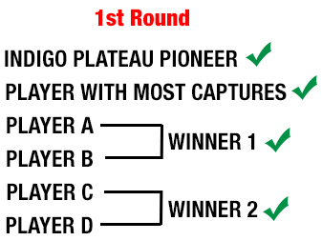

These remaining 4 players go back to the Indigo Plateau space on the board and walk the hexagon again until someone lands on the “Enter the Pokémon League” space. That player can choose his opponent for the semifinals, and the other two players face each other aswell.

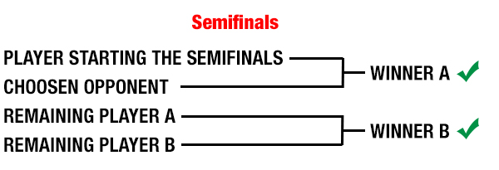

Now the 2 winners are qualified for the final battle: they go back to the Indigo Plateau space and play 3 turns each then face each other. The winner is the new Pokémon Master and the winner of this game.

### 6.1.2) **5 players**

When a player stops at the “Enter the Pokémon League” space, the first round of battles will happen.

The **player with most captures** is already qualified to the semifinals.

The other 4 players battle among themselves, with the Indigo Plateau pioneer choosing his opponent. Winners qualify to the semifinals. Don’t forget that winners of battles on the League draw 3 Item Cards.

After that, the 2 losers battle each other. The winner of this battle is also on the semifinals.

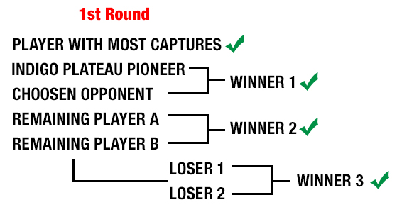

These remaining 4 players go back to the Indigo Plateau space on the board and walk the hexagon again until someone lands on the “Enter the Pokémon League” space. That player can choose his opponent for the semifinals, and the other two players face each other aswell.



Now the 2 winners are qualified for the final battle: they go back to the Indigo Plateau space and play 3 turns each then face each other. The winner is the new Pokémon Master and the winner of this game.

### 6.1.3) **4 players**

When a player stops at the “Enter the Pokémon League” space, the semifinals will happen.

The **player with most captures** chooses his oponente, and the remaining 2 players dueling between themselves. Winners qualify to the semifinals. Don’t forget that winners of battles on the League draw 3 Item Cards.

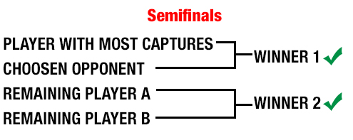

Now the 2 winners are qualified for the final battle: they go back to the Indigo Plateau space and play 3 turns each then face each other. The winner is the new Pokémon Master and the winner of this game.

### 6.1.4) **3 players**

When a player stops at the “Enter the Pokémon League” space, he battles a random opponent. Winners draw 3 Item Cards.

After the battle, all players return to the Indigo Plateau and walk again on the League hexagon, until someone stops at the “Enter the Pokémon League” space.

If the player stopping there has already WON a battle before, he battles the player he hasn’t faced yet. If he hasn’t, he battles a random player.

The first player to win both his opponents in this way is crowned the new Pokémon Master and wins the game.

### 6.1.5) **2 players**

When a player stops at the “Enter the Pokémon League” space, the finals will happen.

After the battle, both players go back to the Indigo Plateau space and walk again until someone stops at the “Enter the Pokémon League”.

The first player with 2 victories is the new Pokémon Master and winner of this game.

### 6.1.6) **Battles**

Battles in the League are done with multiple Pokémon: 3 versus 3. Winners draw 3 Item Cards.

The Pokémon stay in the field until defeated and Items last for only one fight in the whole duel (meaning they get discarded after the roll, as usual – so you can use one Item Card in every fight of these 3v3).

Here’s a **simplified example of a battle in league**:

**1**. Player A is facing Player B in the league.

**2.** Player A sends the Pokémon "A1" and at the same time Player B sends the Pokémon "B1".

**3.** They battle and "A1" wins, he stays on the field.

**4.** Player B chooses who he will send as his "B2".

**5.** "A1" battles "B2". Let's say "A1" wins again.

**6.** Player B chooses who he will send as his "B3".

**7.** Now let's say "B3" beats "A1". "B3" stays on the field while Player A picks his "A2".

Players can use the Hidden Zones near the Stadium for privacy when preparing for the battle, since choosing first what Pokémon you will send into battle is a strategic disavdantage (as seen on **section 4.2.1**).

## **6.2) Elite 4 League:**

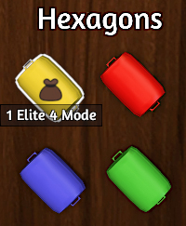In this mode players face the Elite Trainer Cards. The first one to defeat two of them is the Pokémon Master. This League mode is more similar to the endgame of the original Pokémon Master Trainer.

For that mode, gameplay will be the same up to entering the Indigo Plateau. Once there, check the Yellow Trunk in the upper left corner of the table (as shown in the Picture to the right).

There you will find a deck of Elite Trainer Cards Place those cards on the table and shuffle them.

### 6.2.1) **Rules**

On the Indigo Plateau, players will travel until they land on the **Enter the Pokémon League space**, as stated on the start of this section. When a player lands there, shuffle the Elite Trainer Deck and draw a Card from there. The player will battle against this Elite Trainer.

If the player beats the Elite Trainer, draw 2 Item Cards and keep the Elite Trainer Card with you. If the player loses the battle, return the Elite Trainer Card to the deck and shuffle it again.

In order to win the game and become the next Pokémon Master, a player must beat TWO Elite Trainers.

### 6.2.1) **Battling the Elite Trainers**

The battle against the Elite Trainers work similar to a battle with other players.

Every Elite Trainer has 2 Pokémon. Players will first face the one on the left side of the Card and, beating that, will battle against the one on the right side of the card.

The battles work like League Battles (check **section 6.1.6**), but with 2 Pokémon against 2 instead of 3 against 3.

The Elite Trainers, unlike Gym Leaders, roll a dice when battling and will get Power Bonuses as if using Item Cards.

The image below details the components of an Elite Trainer Card:

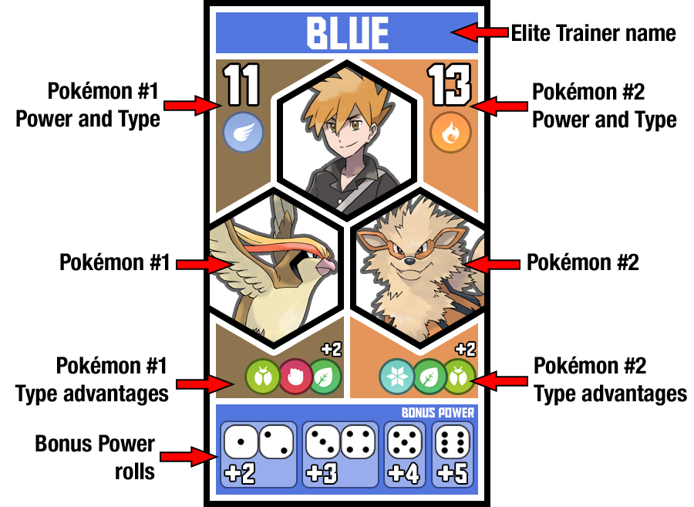

The player will send his Pokémon, roll and use Battle Item Cards like in any battle (section **4.2 Battling** covers that).

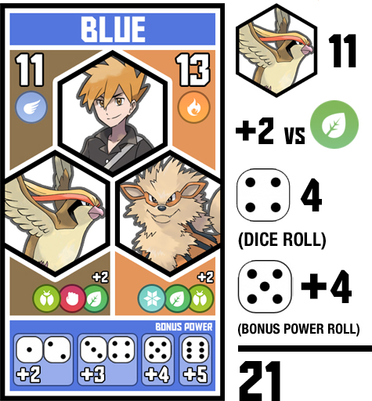The power of the Elite Pokémon is calculed with: **Base power + Type effectiveness + Dice roll + Bonus Power roll.**

**Example**: Blue starts the battle with his Pidgeot (11 power), let’s say he’s battling a grass Pokémon (+2 type advantage). Blue then rolls a 4 for it’s normal roll and then rolls a 5 for his Bonus Power roll, which gives him a +4 bonus. That will give his Pidgeot a total of 21 power, as shown in the image to the right.

Both the player and the Elite Pokémon will stay in the battlefield until defeated. Items and Bonus Power Rolls will last for only one fight in the whole duel (meaning they get discarded after the roll, as usual).

# **7. ITEM GUIDE**

These are items to help you in your journey, acquired through many ways. REMINDER: You can only keep up to 6 Item Cards in your hands. Discard any excess at the end of your turn.

There are 3 types of Item Cards, the difference between them is the moment they are usable. You can check with type of Item it is by checking the icon on the top-right of the Item Card or in the black banner across it.

1. **Common Item**: this item can only be used in your turn.
2. **Quick Item**: this item can be used at any moment.
3. **Battle Item**: this item can only be used in a battle.

Now, for more info on the items:

|  |  |
| --- | --- |
|  | **- BALL CARDS**  These cards help you capture Pokémon. You gotta announce you will use them BEFORE rolling the capture dice. They can add or remove from the result. There are Great Balls, Ultra Balls and Master Balls.  There are 8 Great Balls, 6 Ultra Balls and 2 Master Balls.  See **4.1: Capturing** for more info. |
|  | **- BICYCLE**  You can use this card to play an extra turn after your current turn. You can use more than one bicycle in the same turn. |
|  | **- ESCAPE ROPE**  Use it when walking on the board. You can add or subtract 1 or 2 to the result of the dice you rolled to move. |
|  | **- EXP SHARE**  This card can be activated whenever one of your opponents activates an Event or Super Event Card. Resolve that Event and then copy any effects to you as if you were the one drawing it. |
|  | **- FLY**  Move your pawn to any space on the hexagon you are currently in. Activate the space after getting there. Using this Item must be your only action in your turn. |
|  | **- HONEY**  This card can be used to try to capture a Pokémon that is on the same hexagon as you are. Use it instead of moving normally on your turn. |
|  | **- LURE MODULE**  Swap the positions of two Pokémon of the same color in the board. They may be revealed or not. |
|  | **- MEDICINE**  This card can be used when you lose a battle. Just revive the Pokémon that lost and restart the battle. This card is a good counter to Power Bonuses, because if they were used in battle, they are discarded, and the battle resets without them.  Check **4.2: Battling** for more info on battles. |
|  | **- POKÉ DOLL**  This Item can block any direct effect caused to you, be it from another Item, Event or any effect caused by a city space.  It’s always useful to keep one with you to block an unwanted trade or avoid a battle you don’t want to face right now.  It can be used to block ANOTHER Poké Doll. |
|  | **- POKE FLUTE**  You can use this card whenever an Event Card is activated. Cancel the Event, draw another and activate it.  This effect can be blocked by a Poké Doll. |
|  | **- POKÉNAV PLUS**  This items forces a player to discard his Trainer Card and draw two other Trainer Cards. This can be used to change your own Trainer Card.  This effect can be blocked by a Poké Doll. |
|  | **- POWER BONUSES**  **(VITAMINS, X BONUSES, TYPE-ENHANCING ITEMS)**  These Items increase the Power of your Pokémon for a single battle. There are +2 and +3 bonuses, that can be used on any Pokémon, and +4 bonuses that can only be used on Pokémons of the type shown in the card.  Check **4.2: Battling** for more info on battles. |
|  | **- QUICK TRADE**  You can swap one of your Pokémon with any Pokémon face-up of the same color, provided it is on the same hexagon your pawn currently is. |
|  | **- RARE CANDY**  You can use this card when there is a revealed Pokémon on the board that is Blue or weaker and of the same evolutionary Family as any of your Pokémon.  Just get this Pokémon, you don’t need to roll capture dices. |
|  | **- REPEL**  You can use this item whenever a Pokémon is revealed on the board. Just swap the revealed Pokémon with the next Pokémon of the same color from the pile. Don’t forget to shuffle the Pokémon pile afterwards.  This can be blocked by any Poké-Doll. |
|  | **- ROCKET ATTACK**  Choose an opponent and just steal a random Item Card from their hand. This can be blocked by a Poké-Doll. |
|  | **- TIME TRAVEL**  This item forces a reroll of any dice. This can be used anytime after any roll of the dice made by you or an opponent.  This effect can be blocked by a Poké Doll. |

# **8. EVENT GUIDE**

The world of Pokémon is full of people, places and events that you can find at any time. These cards are drawn **whenever you land on the ‘!’ space on the board**.

When buying one of these just activate the command on the card.

Most of the Event Cards are pretty simple and reading the card itself will be enough. For that, this guide will only detail some Events.

Another general rule is: whenever an Event Card targets a player meeting some condition and more than a player meets that condition (example: an event that benefits the player with most captures and two players have the same amount of captures), **the player who drew the Event will choose who is affected by it**.

|  |  |
| --- | --- |
|  | **- ALTERNATIVE GYM**  You can battle your next Gym Leader with this card, from wherever you are on the board. You will choose the adversary among the Gym Leaders not in the game that give the same badge as the one you want to face (1-2, 3-4 or 5-6). |
|  | **- BLOCKED ROUTE**  You can get a Blue or weaker Pokémon that is on your hexagon for free.That Pokémon can be revealed or not.  If there are no Blue or weaker Pokémon on your hexagon, you can TRY the capture of any Pokémon there.  After that, skip your next turn. A Poké-Doll can block the that turn skip. |
|  | **- CHAIRMAN ROSE**  With this event you get a free Blue Pokémon. Get the next Blue Pokémon from the pile out of the game and add them to your team for free. |
|  | **- DELIBIRD’S GIFT**  With this event you get a free Pokémon from the same color as the space you activated this event. You can pick from the revealed Pokémon on the board or a random face-down Pokémon.  If you activate this Event from a City, just check the tier of the hexagon for the color (Green/Blue/Red). If you activate this Event from the Indigo Plateau you can choose any color (with the exception of Yellow). |
|  | **- DUEL**  This Event forces a battle between you and an opponent you choose. Some types will get +1 and others -1 in battle, depending on the Duel Event. The prize is also different for every Duel Event.  Some more info on **4.2: Battling** and **4.2.1: Duel Events**.  The duel can be avoided by a Poké Doll. |
|  | **- GS BALL**  With this event you get a free Pink Pokémon. Get the next Pink Pokémon from the pile out of the game and add them to your team for free.  That Pink Pokémon, however, gets a +1 permanent token similar to the ones for locked/upgraded Pokémon (check **5.4: Locking and Upgrading a Pokémon**). That Pokémon, however, is not protected from trading.  Remember to delete this Event from the game after using it. |
|  | **- HEAVY STORM**  This event affects the hexagon where the player who activated it was standing. Remove every Pokémon chip in the área to the pile, shuffle it and re-fill the hexagon with face-up Pokémon. |
|  | **- IMPOSTER OAK**  You and an opponent you choose will discard all your Item Cards and draw only 2 Items after that.  That effect can be blocked by a Poké Doll. |
|  | **- JIRACHI’S WISH**  Draw 3 Event Cards. Assign them to 3 different players. You can target yourself for one of the Events. Nobody can activate more than 1 Event through this card (so, if you only have 2 players left, only 2 of those 3 Events will be assigned.) |
|  | **- KIMONO SISTERS**  When you draw this event, name a Pokémon Type and a Color (Pink, Green, Blue or Red – up to the color of your current space). Now check the Pokémon Pile of the chosen color and get the next Pokémon of said type. If there are no results, choose another color and type. |
|  | **- LEGENDARY POKÉMON**  Try to capture a Yellow Pokémon. More on **4.5: Legendary Pokémon**. |
|  | **- POKE FANS**  You can swap your Trainer Card with any opponent, after that, both of you will draw 2 Item Cards.  That effect can be blocked with a Poké Doll. If it is blocked, neither will draw Item Cards. |
|  | **- POKEMANIAC**  The top three players with most captures will get, respectively, a Blue, a Green and a Pink Pokémon for free. The Pokémon will be random and unrevealed, from the pile.  In case of a draw in the number of captures, whoever activates this Event will decide on who gets what. |
|  | **- POKEMON DAYCARE**  Check the strongest Pokémon Every player owns (including bonuses from Evolution). Whoever owns the weaker among those Pokémon gets a free random Pokémon of the same color as the board space in which this Event was activated.  In case of a draw whoever activated this Event chooses who will get the free Pokémon. |
|  | **- POKÉMON EGG**  With this event you get a free Pink Pokémon. Get the next Pink Pokémon from the pile out of the game and add them to your team for free. |
|  | **- POKÉMON FOSSIL**  With this event you get a free Green Pokémon. Get the next Green Pokémon from the pile out of the game and add them to your team for free. |
|  | **- PREPARE FOR TROUBLE**  This is a continuous event, which means that it will keep affecting every player for 2 turns.  When this is active, every player – except for whoever activated this event – can only move 1 space on the board, no matter their dice roll or Trainer Card (if a player has Hiker, for instance, they will still only be able to move 1 space.). |
|  | **- PROFESSOR BIRCH**  If two or more players are tied as “the player with fewer Item Cards”, whoever activated the Event chooses who gets the benefit. |
|  | **- REGIONAL MAP**  You can try to capture any face-up Pokémon on the board. If there are no face-up Pokémon anywhere this event will have no effect. |
|  | **- ROCKET BRIBE**  Until your next turn, every Event Card one of your opponents draw will have its’ effects copied to you, as if you were the one drawing it. Then, if you successfully copied at least one Event, skip your next turn. |
|  | **- S.S. ANNE**  This Event FORCES a Pokémon Trade. Both Pokémon involved on a Trade gotta be of the same color. This is a very strong Event Card, since you can use it to make your team more complete or you can also make an enemy weaker, disrupting an evolutionary family.  (You only trade 1 Pokémon for 1 Pokémon, even if it has evolutions).  Also, after reaching the 6th Badge and the Pokémon league, players can name Pokémon families that become untradeable (check **5.4: Locking and Upgrading a Pokémon**).  This effect can be blocked by a Poké Doll. |
|  | **- SKETCHY SALESMAN**  The secondary effect on this event is OPTIONAL. You may send two of your Pokémon of the same color to the Pokémon Pile out of the game and draw one Pokémon from that pile.  That is more useful later in the game to recycle Pink or Green Pokémon that do not contribute to your main evolution families. |
|  | **- TEAM AQUA STRIKES**  Every player in the game must discard their Item Cards. After that, everyone draws the same number of Items that they discarded.  This effect can be blocked by a Poké Doll. |
|  | **- TEAM MAGMA STRIKES**  Every player in the game must discard their Trainer Cards. After that, everyone draws another Trainer Card from the pile.  This effect can be blocked by a Poké Doll. |
|  | **- TEAM ROCKET STRIKES**  First, everyone draws an Item Card. Then, everyone must steal a random Item Card from the hands of the player to their right. |
|  | **- TRADE**  This Event FORCES a Pokémon Trade. Both Pokémon involved on a Trade gotta be of the same color. This is a very strong Event Card, since you can use it to make your team more complete or you can also make an enemy weaker, disrupting an evolutionary family.  (You only trade 1 Pokémon for 1 Pokémon, even if it has evolutions).  Also, after reaching the 6th Badge and the Pokémon league, players can name Pokémon families that become untradeable (check **5.4: Locking and Upgrading a Pokémon**).  This effect can be blocked by a Poké Doll. |

# **9. SUPER EVENT GUIDE**

These are like Event Cards, but stronger. Drawn whenever you land on the yellow “!” space on the board, they’re only found in the Indigo Plateau, right before the Pokémon League starts, but in rare ocasions you might just bump into one of them.

|  |  |
| --- | --- |
|  | **- AQUA OPERATION**  Every one of your opponents will discard one Item Card to a pile. Then, you might check those discarded Items and draw up to 3 Items from them and the Item Card pile. So, for instance, you could get one of the discarded and two from the pile.  The discarding can be blocked by a Poké-Doll. |
|  | **- ARCEUS’ WISH**  Draw 2 Super Event Cards. Assign them to 2 different players. You can target yourself for one of the Super Events. |
|  | **- BILL’S MACHINE**  Reveal a Pink, a Green, a Blue and a Red Pokémon on the board. After that you can try to capture two among those four. |
|  | **- BOOSTED POKENAV**  Draw 3 Trainer Cards from the pile. Remember you can only keep one Trainer Card active, so you gotta discard unused Trainers by the end of your turn. |
|  | **- EGG INCUBATORS**  With this event you get 3 free Pink Pokémon. Get the next 3 Pink Pokémon from the pile out of the game and add them to your team for free. |
|  | **- FOSSIL EXPERT**  Reveal the next 3 Green Pokémon from the pile out of the game. You can choose two of them and add them to your team for free. |
|  | **- GALACTIC OPERATION**  Draw 3 Item Cards and, if you want to, you can send one of your opponents that is currently in your Hexagon to a City Space in an adjacent hexagon. |
|  | **- LEGENDARY POKÉMON**  Draw the next 4 Yellow Pokémon out of the game, choose one of them and try to capture it. More on **4.5: Legendary Pokémon**. |
|  | **- MAGMA OPERATION**  Every one of your opponents will discard their Trainer Cards to a pile. Then, you might check those discarded Trainers and swap your Trainer Card with one of them.  The discarding can be blocked by a Poké-Doll. |
|  | **- MISSINGNO**  Draw 2 Item cards and get a free random and unrevealed Blue Pokémon for free. |
|  | **- MR. BRINEY’S BOAT**  After drawing this Super Event, play an extra turn. Until your next turn you can add or subtract 1 to to the movement dice roll of every player on your hexagon. That includes you in your extra turn. |
|  | **- OLD AMBER**  With this event you get a free Red Pokémon. Get the next Red Pokémon from the pile out of the game and add them to your team for free. |
|  | **- POKÉMON MUSEUM**  Draw four Item Cards. |
|  | **- ROCKET OPERATION**  You must choose one of the two options the card gives you. Either steal one item from two players or two items from one player.  This effect can be blocked by a Poké Doll. |
|  | **- TRADE**  This Event FORCES a Pokémon Trade. Both Pokémon involved on a Trade gotta be of the same color. This is a very strong Event Card, since you can use it to make your team more complete or you can also make an enemy weaker, disrupting an evolutionary family.  (You only trade 1 Pokémon for 1 Pokémon, even if it has evolutions).  Also, after reaching the 6th Badge and the Pokémon league, players can name Pokémon families that become untradeable (check **5.4: Locking and Upgrading a Pokémon**).  This effect can be blocked by a Poké Doll. |

# **10. TRAINER CARD GUIDE**

These cards represent your specialty as a trainer and grant you passive bonuses. There is a space on every player’s pad for it.

You draw one of them at the start of the game and every player has one trainer card active at all times. There are Events and Items that will cause drawing of new Trainer Cards or trading of Trainer Cards between players, however, each player can only keep one of them.

|  |  |
| --- | --- |
|  | **- TYPE SPECIALISTS**  There are 13 type specialist Trainer Cards. They add +1 power in battle to Pokémon of the specific types shown on the card. Also, they have a bonus when rolling for a capture on their specific types – that bonus can be stacked with Poké-Ball items. |
|  | **- BLUE**  Whenever you catch a Pokémon, draw an Item Card. Note that this effect is also applied for Pokémon obtained through Events or Badge rewards. |
|  | **- BACKPACKER**  With that Trainer you can keep 8 Item Cards on your hands. |
|  | **- BRENDAN**  Whenever you’re in battle, you can discard an Item Card and receive +1 power. That Item discard must occour before the dice roll, like if you were using a Item Card to add power. You can stack this bonus with your usual battle items. |
|  | **- CHEREN**  Every Pokémon you own will get +1 power. However, you can only hold up to 3 Item Cards on your hands. |
|  | **- CYNTHIA**  Whenever a player in the same hexagon you are in fails a capture roll, you can roll for capture if you want. If the Pokémon was not weakened, your roll will take place before placing the weakened Pokémon token on it.  You can use Poké-Ball Item Cards on your attempt. |
|  | **- ETHAN**  Blue Pokémon get +1 power in battle. That only applies if you send the Blue Pokémon as active (so a Blue Pokémon that evolves into a Red Pokémon won’t get the bonus if you send that Red Pokémon as active). |
|  | **- GREEN**  You can roll 2 dices before moving on the board and pick one of them as the result. |
|  | **- HAU**  At the start of your turn you may stay where you are and activate the boardspace you’re in. If it’s NOT a Pokémon space you need to discard an Item Card before doing that. |
|  | **- HIKER**  You can move one or two spaces on the board instead of rolling a dice. |
|  | **- LYRA**  If you want to, you can skip your turn and draw 2 Item Cards. |
|  | **- MAY**  Green Pokémon get +2 power in battle. That only applies if you send the Green Pokémon as active (so a Green Pokémon that evolves into a Blue/Red Pokémon won’t get the bonus if you send that Blue/Red Pokémon as active).  Also, you can discard this Trainer to copy the effects of any Event an opponent activates. |
|  | **- RED**  Whenever you try to capture a Pokémon, you can roll 2 dices instead of 1. |
|  | **- SILVER**  Whenever roll a 1 on any dice roll you can draw an Item Card. |
|  | **- WALLY**  Pink Pokémon get +2 power. Also, whenever you try to capture a Pokémon from the same evolutionary family as one of your own Pokémon, you can add or subtract 1 to the capture roll. That can be stacked with Poké-Ball Item Cards. |

# **11. APPENDIX: POKÉMON EVOLUTION GUIDE / POWER CHART**

## 

## **DRAGON**

|  |  |  |
| --- | --- | --- |
| Dratini | Dragonair | Dragonite (8) |
| Gible | Gabite | Garchomp (8) |
| Rayquaza (11) |  |  |
| Horsea | Seadra | Kingdra (7) |
| Mareep | Flaaffy | Ampharos (7) |
| Tyrunt | Tyrantrum (8) |  |
| Skrelp | Dragalge (8) |  |
| Goomy | Sliggoo | Goodra (6) |
| Swablu | Altaria (7) |  |
| Druddigon (6) |  |  |

## **DARK/GHOST**

|  |  |  |
| --- | --- | --- |
| Gastly | Haunter | Gengar (8) |
| Larvitar | Pupitar | Tyranitar (8) |
| Darkrai (11) |  |  |
| Duskull | Dusclops | Dusknoir (7) |
| Sandile | Krokorok | Krookodile (7) |
| Golett | Golurk (8) |  |
| Murkrow | Honchkrow (8) |  |
| Litwick | Lampent | Chandelure (6) |
| Honedge | Doublade | Aegislash (6) |
| Eevee | Umbreon (7) |  |
| Houndour | Houndoom (7) |  |
| Skorupi | Drapion (6) |  |
| Absol (8) |  |  |

## **ELECTRIC**

|  |  |  |
| --- | --- | --- |
| Elekid | Electabuzz | Electivire (8) |
| Magnemite | Magneton | Magnezone (8) |
| Zapdos (11) |  |  |
| Shinx | Luxio | Luxray (7) |
| Mareep | Flaaffy | Ampharos (7) |
| Blitzle | Zebstrika (8) |  |
| Pichu | Pikachu | Raichu (6) |
| Geodude | Graveler | Golem (6) |
| Eevee | Jolteon (7) |  |
| Helioptile | Heliolisk (7) |  |
| Voltorb | Electrode (6) |  |
| Electrike | Manectric (5) |  |

## **FIRE**

|  |  |  |
| --- | --- | --- |
| Charmander | Charmeleon | Charizard (8) |
| Torchic | Combusken | Blaziken (8) |
| Moltres (11) |  |  |
| Magby | Magmar | Magmortar (7) |
| Fletchling | Fletchinder | Talonflame (7) |
| Growlithe | Arcanine (8) |  |
| Larvesta | Volcarona (8) |  |
| Litwick | Lampent | Chandelure (6) |
| Eevee | Flareon (7) |  |
| Houndour | Houndoom (7) |  |
| Vulpix | Ninetales (6) |  |
| Numel | Camerupt (6) |  |

## **FLYING**

|  |  |  |
| --- | --- | --- |
| Charmander | Charmeleon | Charizard (8) |
| Dratini | Dragonair | Dragonite (8) |
| Articuno (11) |  |  |
| Zapdos (11) |  |  |
| Moltres (11) |  |  |
| Zubat | Golbat | Crobat (7) |
| Fletchling | Fletchinder | Talonflame (7) |
| Murkrow | Honchkrow (8) |  |
| Magikarp | Gyarados (8) |  |
| Pidgey | Pidgeotto | Pidgeot (6) |
| Caterpie | Metapod | Butterfree (6) |
| Swablu | Altaria (7) |  |
| Aerodactyl (8) |  |  |
| Natu | Xatu (6) |  |

## **GRASS/BUG**

|  |  |  |
| --- | --- | --- |
| Bulbasaur | Ivysaur | Venusaur (8) |
| Chicorita | Bayleef | Meganium (8) |
| Celebi (11) |  |  |
| Venipede | Whirlipede | Scolipede (7) |
| Oddish | Gloom | Vileplume (7) |
| Larvesta | Volcarona (8) |  |
| Exeggcute | Exeggutor (8) |  |
| Weedle | Kakuna | Beedrill (6) |
| Caterpie | Metapod | Butterfree (6) |
| Scyther | Scizor (7) |  |
| Snover | Abomasnow (7) |  |
| Pinsir (8) |  |  |
| Venonat | Venomoth (5) |  |

## **GROUND**

|  |  |  |
| --- | --- | --- |
| Swinub | Piloswine | Mamoswine (8) |
| Gible | Gabite | Garchomp (8) |
| Groudon (11) |  |  |
| Rhyhorn | Rhydon | Rhyperior (7) |
| Sandile | Krokorok | Krookodile (7) |
| Golett | Golurk (8) |  |
| Onix | Steelix (8) |  |
| Nidoran | Nidorino | Nidoking (6) |
| Wooper | Quagsire (7) |  |
| Phanpy | Donphan (7) |  |
| Cubone | Marowak (6) |  |
| Numel | Camerupt (6) |  |

## **ICE/FAIRY**

|  |  |  |
| --- | --- | --- |
| Swinub | Piloswine | Mamoswine (8) |
| Ralts | Kirlia | Gardevoir (8) |
| Articuno (11) |  |  |
| Spheal | Sealeo | Walrein (7) |
| Cleffa | Clefairy | Clefable (7) |
| Smoochum | Jynx (8) |  |
| Koffing | Weezing (8) |  |
| Azurill | Marill | Azumarill (6) |
| Igglybuff | Jigglypuff | Wigglytuff (6) |
| Eevee | Sylveon (7) |  |
| Snover | Abomasnow (7) |  |
| Lapras (8) |  |  |
| Sandshrew | Sandslash (6) |  |

## **NORMAL/STEEL**

|  |  |  |
| --- | --- | --- |
| Happiny | Chansey | Blissey (8) |
| Magnemite | Magneton | Magnezone (8) |
| Registeel (11) |  |  |
| Slakoth | Vigoroth | Slaking (7) |
| Beldum | Metang | Metagross (7) |
| Onix | Steelix (8) |  |
| Munchlax | Snorlax (8) |  |
| Honedge | Doublade | Aegislash (6) |
| Igglybuff | Jigglypuff | Wigglytuff (6) |
| Helioptile | Heliolisk (7) |  |
| Scyther | Scizor (7) |  |
| Kangskan (8) |  |  |
| Sandshrew | Sandslash (6) |  |

## **POISON**

|  |  |  |
| --- | --- | --- |
| Bulbasaur | Ivysaur | Venusaur (8) |
| Gastly | Haunter | Gengar (8) |
| Zubat | Golbat | Crobat (7) |
| Oddish | Gloom | Vileplume (7) |
| Koffing | Weezing (8) |  |
| Skrelp | Dragalge (8) |  |
| Nidoran | Nidorino | Nidoking (6) |
| Caterpie | Metapod | Butterfree (6) |
| Grimer | Muk (7) |  |
| Skorupi | Drapion (6) |  |
| Venonat | Venomoth (5) |  |

## **PSYCHIC**

|  |  |  |
| --- | --- | --- |
| Abra | Kadabra | Alakazam (8) |
| Ralts | Kirlia | Gardevoir (8) |
| Mewtwo (11) |  |  |
| Slowpoke | Slowbro | Slowking (7) |
| Beldum | Metang | Metagross (7) |
| Smoochum | Jynx (8) |  |
| Exeggcute | Exeggutor (8) |  |
| Gothita | Gothorita | Gothitelle (6) |
| Igglybuff | Jigglypuff | Wigglytuff (6) |
| Meditite | Medicham (7) |  |
| Staryu | Starmie (7) |  |
| Natu | Xatu (6) |  |
| Drowzee | Hypno (5) |  |

## **ROCK/FIGHTING**

|  |  |  |
| --- | --- | --- |
| Torchic | Combusken | Blaziken (8) |
| Larvitar | Pupitar | Tyranitar (8) |
| Regirock (11) |  |  |
| Machop | Machoke | Machamp (7) |
| Rhyhorn | Rhydon | Rhyperior (7) |
| Kabuto | Kabutops (8) |  |
| Tyrunt | Tyrantrum (8) |  |
| Geodude | Graveler | Golem (6) |
| Poliwag | Poliwhirl | Poliwrath (6) |
| Tyrogue | Hitmonchan (7) |  |
| Meditite | Medicham (7) |  |
| Aerodactyl (8) |  |  |
| Mankey | Primeape (5) |  |

## **WATER**

|  |  |  |
| --- | --- | --- |
| Squirtle | Wartortle | Blastoise (8) |
| Totodile | Croconaw | Feraligatr (8) |
| Kyogre (11) |  |  |
| Horsea | Seadra | Kingdra (7) |
| Slowpoke | Slowbro | Slowking (7) |
| Magikarp | Gyarados (8) |  |
| Kabuto | Kabutops (8) |  |
| Azurill | Marill | Azumarill (6) |
| Poliwag | Poliwhirl | Poliwrath (6) |
| Staryu | Starmie (7) |  |
| Wooper | Quagsire (7) |  |
| Lapras (8) |  |  |